DOCUMENT FOR ARCHIVE COMMAND FAILED SCRIPT

Hi team ,

I have written a script to detect archive command failures If any logs are generated about archive command failures, it will immediately send us an alert on no-reply email, making it simple for us to keep an eye out for any warnings on the database server.
Also its giving us only new logs because we have given condition below

if [[ $NEWCOUNT -gt $value ]]; then
count="$((NEWCOUNT-value))
it will exclude old record and give us new record only .
Via alert

crontab -l

0 * * * * sh -x /home/postgres/archive_commandfailed.sh > /home/postgres/archive_command1.log 2>&1 &

Archive command FAiled scripts
************BEGINING*************
#!/bin/bash
#Set the variable which equal to zero
DATE=`date +%Y%m%d`
RECIPIENTS='postgresdbasupport@bajajfinserv.in'
value=`cat /tmp/archivecmdfail.log |wc -l`
NEWCOUNT=`grep -oP '(?<=archive command failed).*' /data/pgdata14/log/postgresql-${DATE}* | wc -l`
grep -oP '(?<=archive command failed).*' /data/pgdata14/log/postgresql-${DATE}* > /tmp/failed_user
if [[ $NEWCOUNT -gt $value ]]; then
count="$((NEWCOUNT-value))"
grep -i 'archive command failed' /data/pgdata14/log/postgresql-${DATE}* | tail -n $count >> /tmp/archivecmdfail.log
tail -n $count /tmp/archivecmdfail.log | mailx -s "archive command failed for host: $hostname" $RECIPIENTS
fi

End of scirpts******************

vi archive_commandfailed.sh

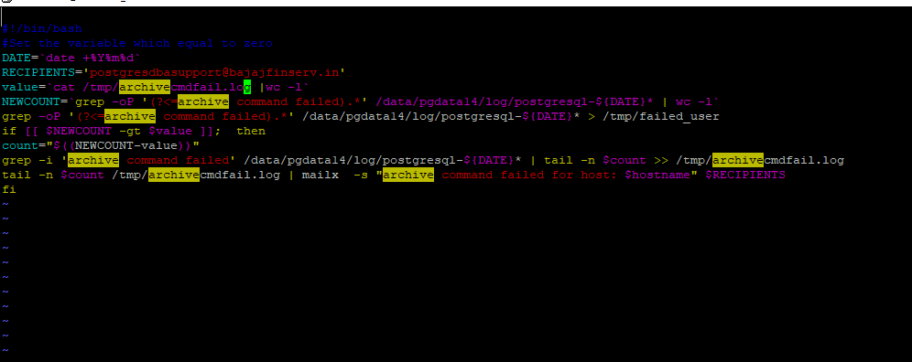
give execute permission using below command

chmod -x archive_commandfailed.sh

log file**************

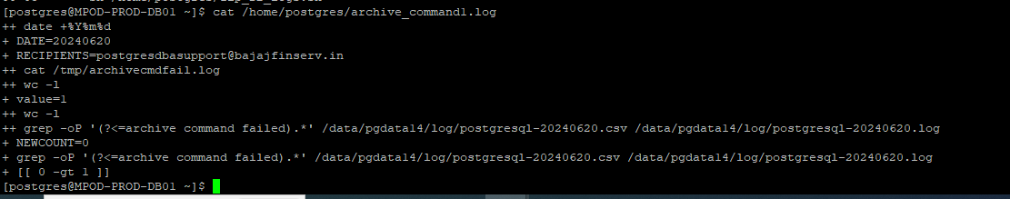
Its successfully ran and giving alert as well when error is occure.

**************Thanks *******************************************

Regards
Akil Shaikh

